Contents

Eastern Cape 2

Pettitt test 2

Mann-kendall test 3

Sens slope 4

KWA-ZULU NATAL 5

Pettitt test 5

Mann-Kendall test 6

Sens slope 7

GAUTENG 8

Pettit test 8

Mann-Kendall test 9

Sens slope 10

Free State 11

Pettitt test 11

Mann-Kendall test 12

Sens slope 12

Western Cape 14

Pettitt test 14

Mann-Kendall test 15

Sens slope 16

Nothern Cape 17

Pettitt test 17

Mann-Kendall test 18

Sens slope 19

Limpopo 20

Pettitt test 20

Mann-Kendall test 21

Sens slope 22

North West 23

Pettitt test 23

Mann-Kendall test 24

Sens slope 25

# Eastern Cape

## Pettitt test

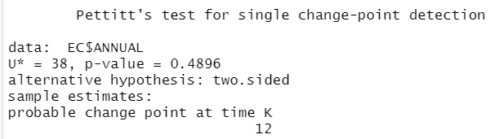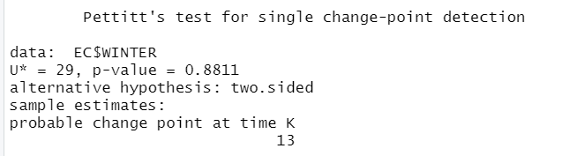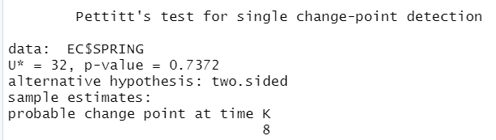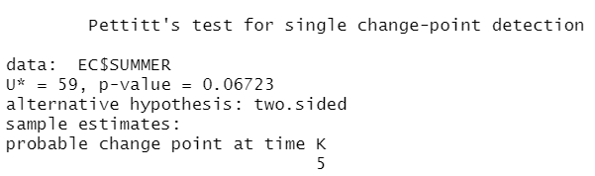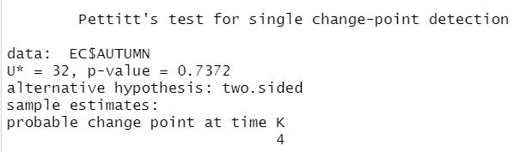

## Mann-kendall test

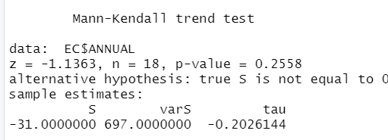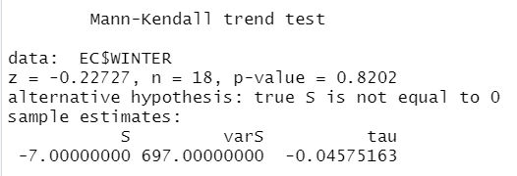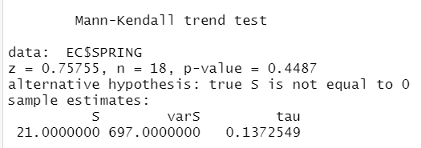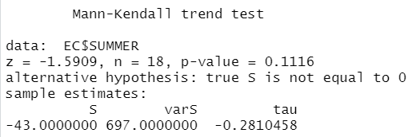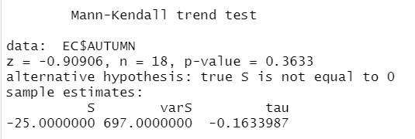

## Sens slope

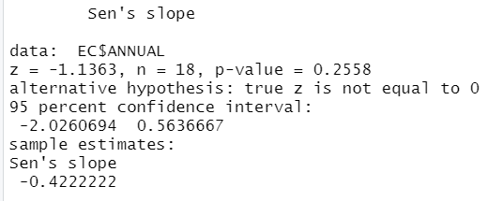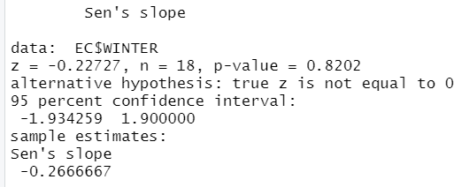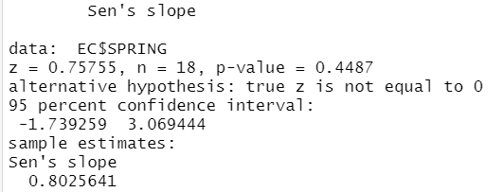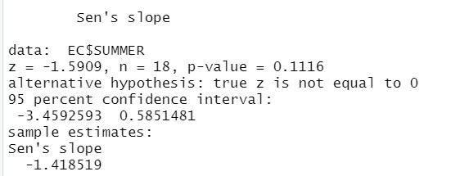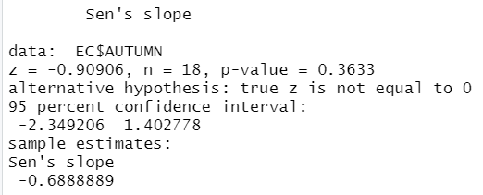

# KWA-ZULU NATAL

## Pettitt test

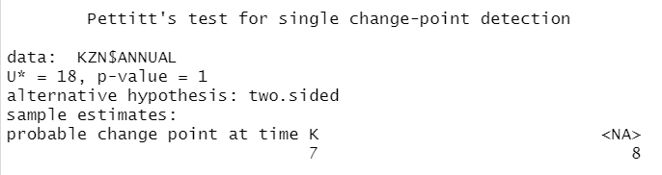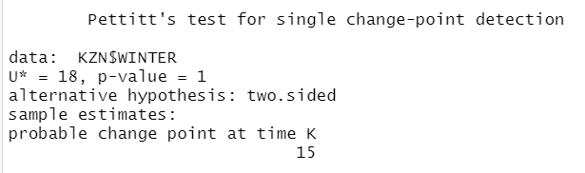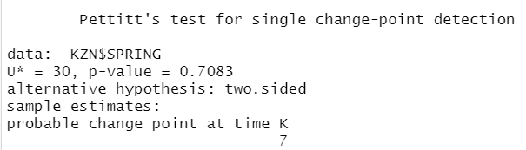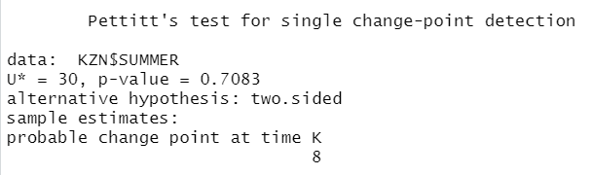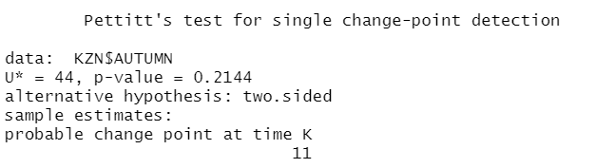

## Mann-Kendall test

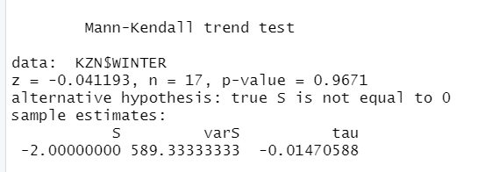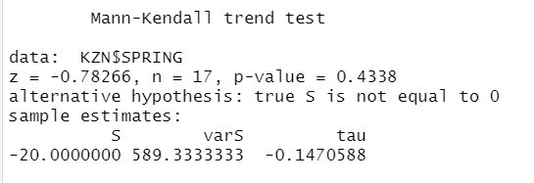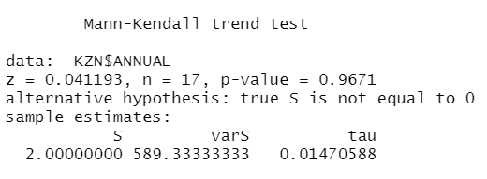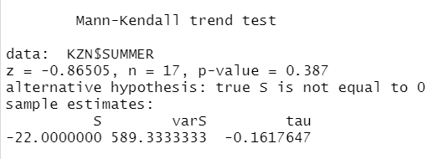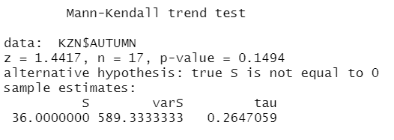

## Sens slope

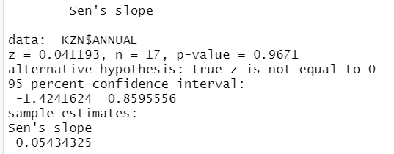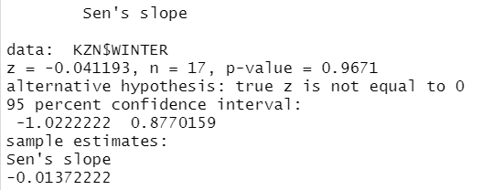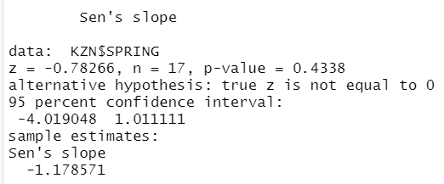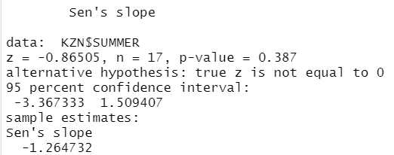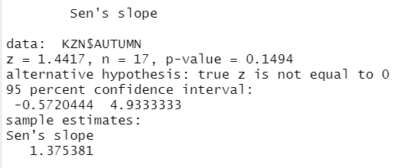

# GAUTENG

## Pettit test

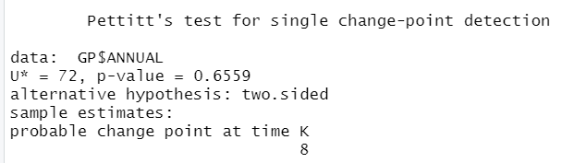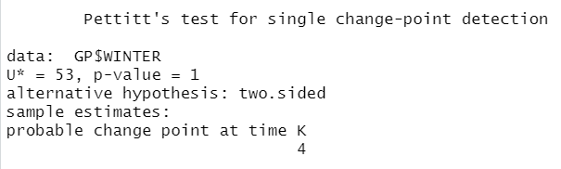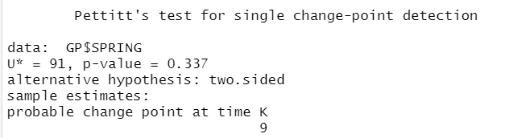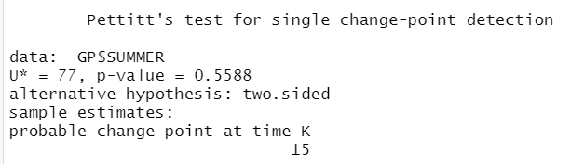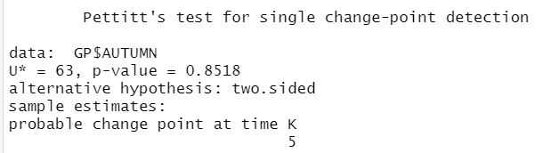

## Mann-Kendall test

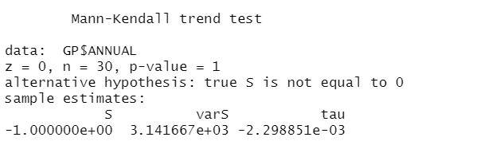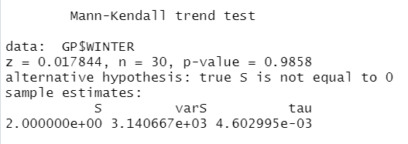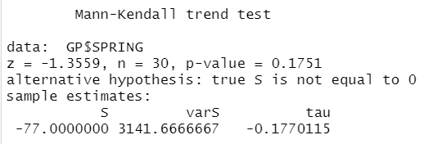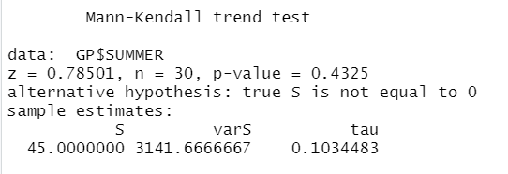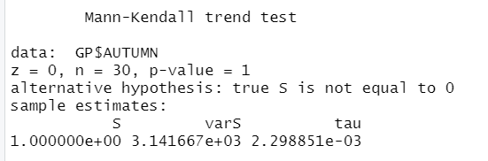

## Sens slope

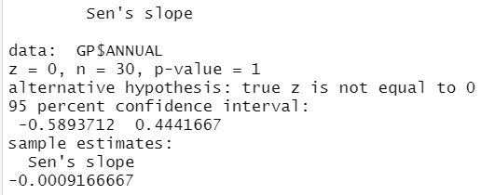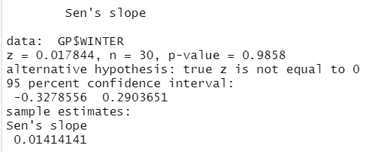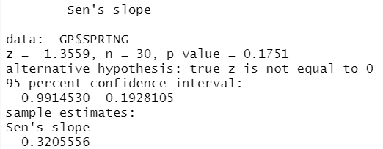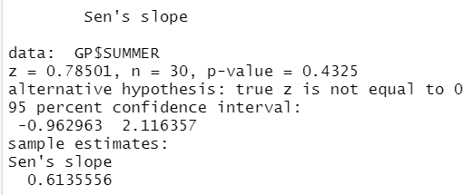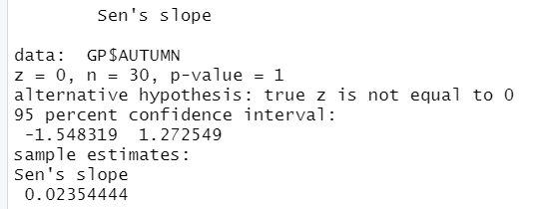

# Free State

## Pettitt test

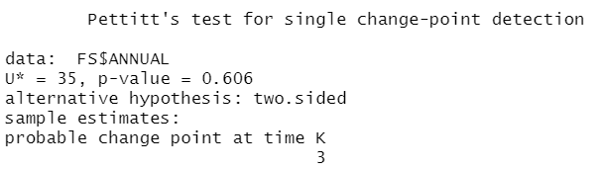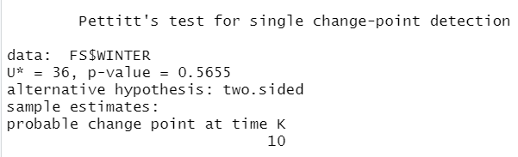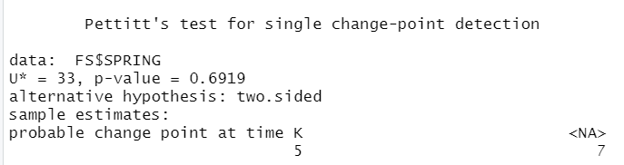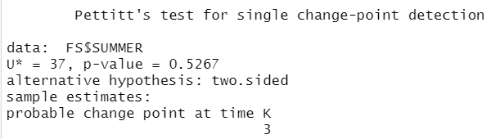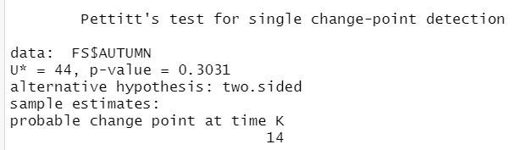

## Mann-Kendall test

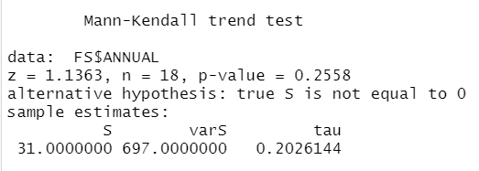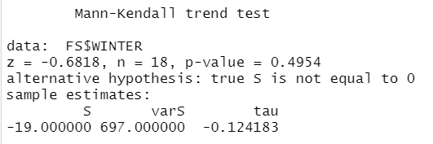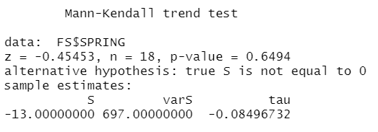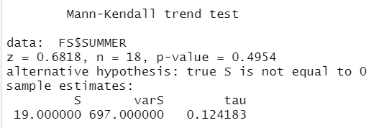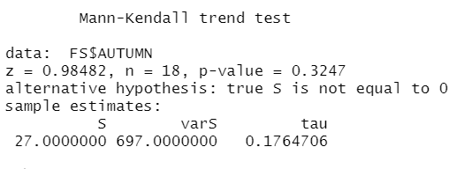

## Sens slope

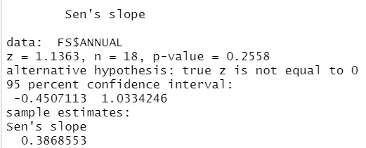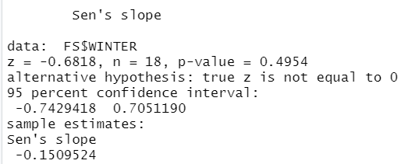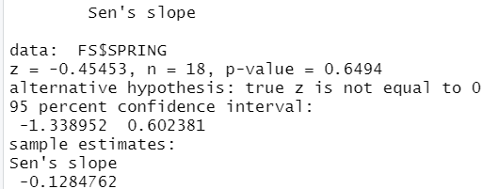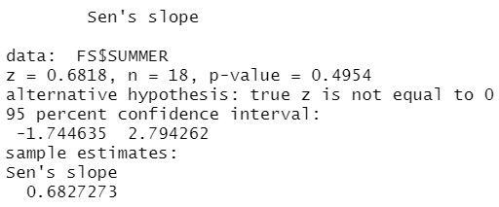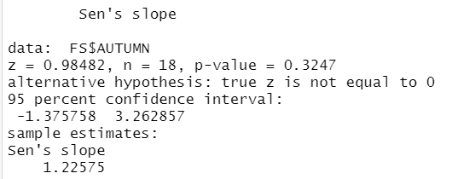

# Western Cape

## Pettitt test

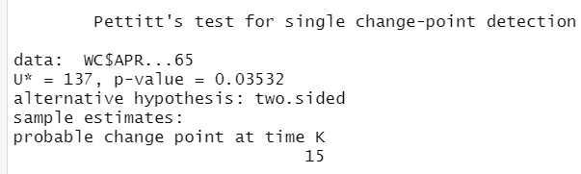

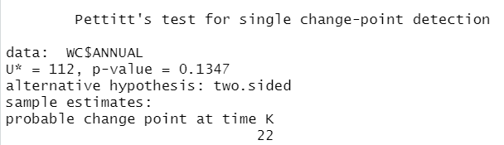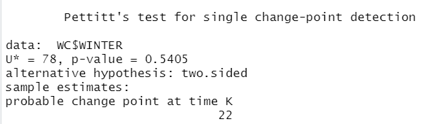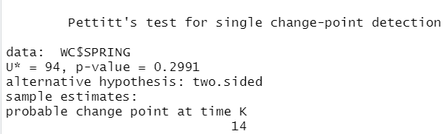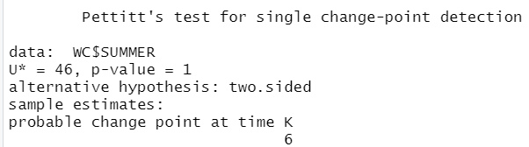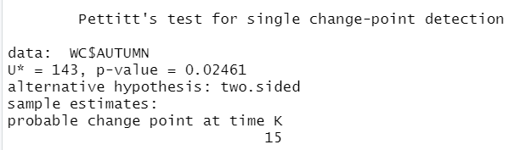

## Mann-Kendall test

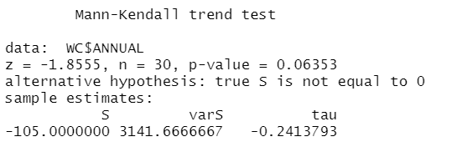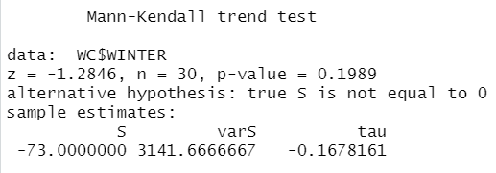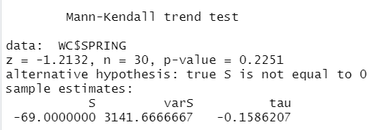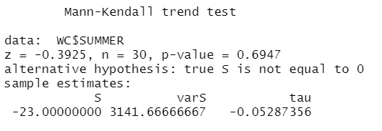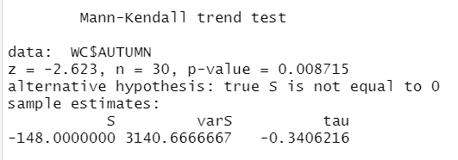

## Sens slope

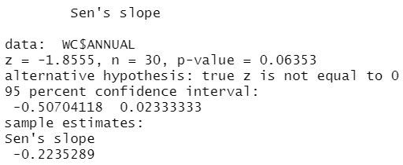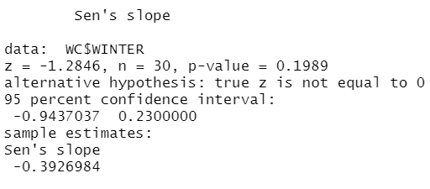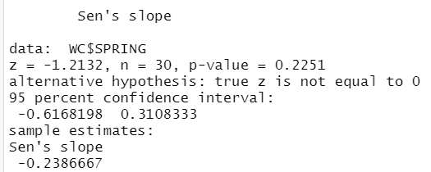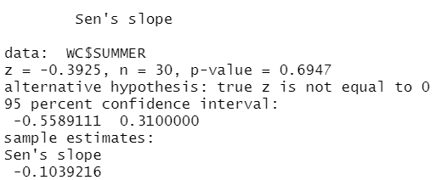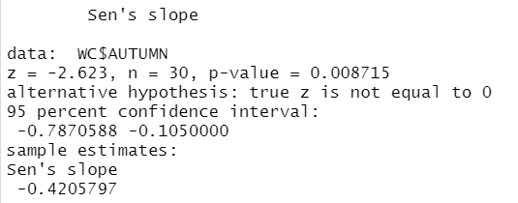

# Nothern Cape

## Pettitt test

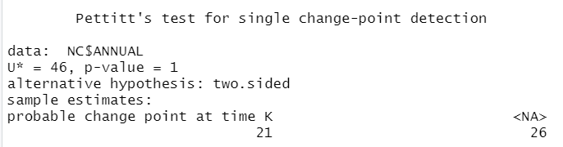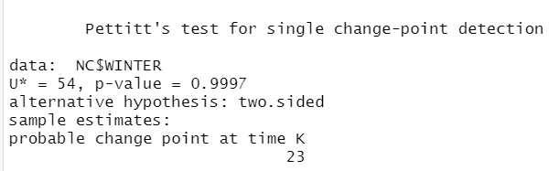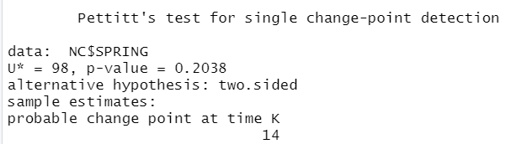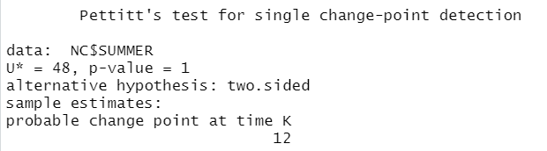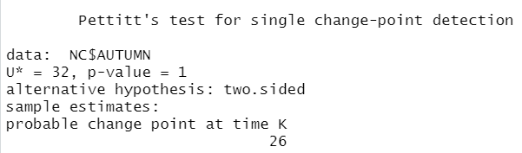

## Mann-Kendall test

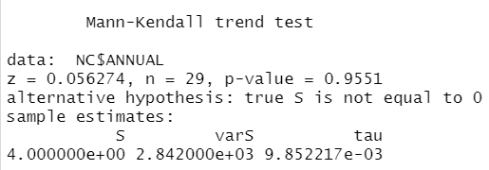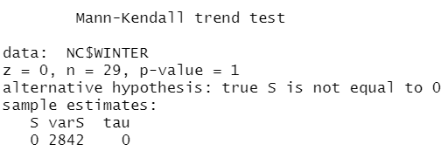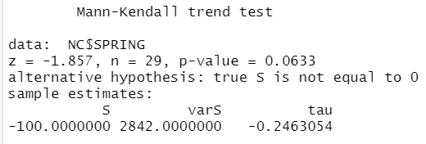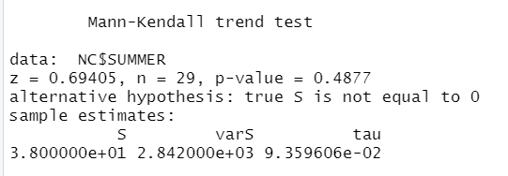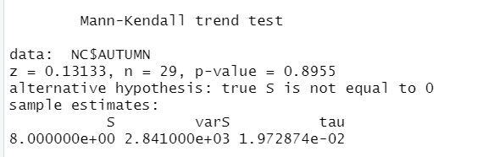

## Sens slope

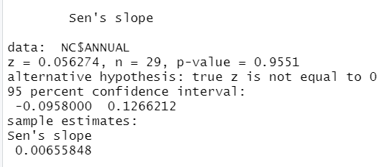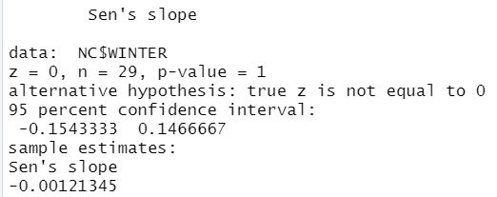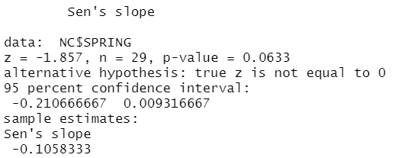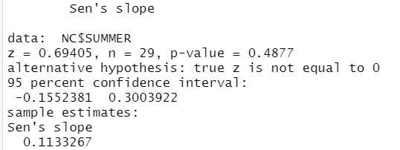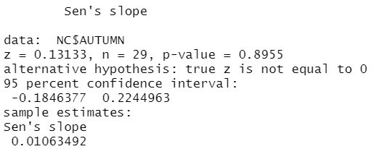

# Limpopo

## Pettitt test

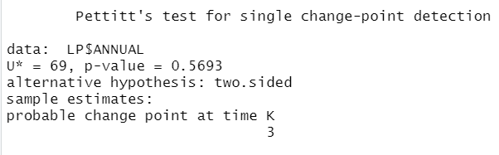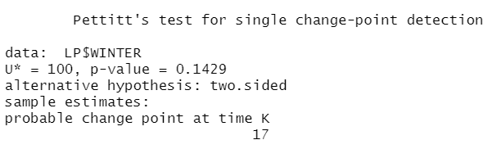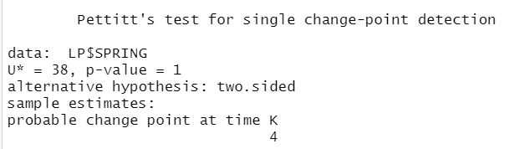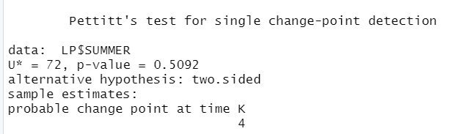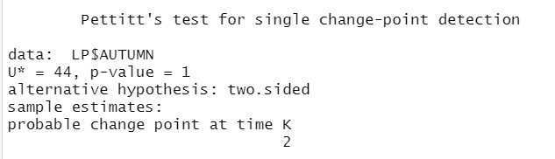

## Mann-Kendall test

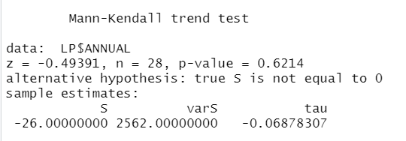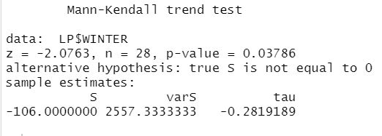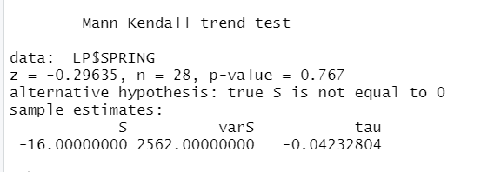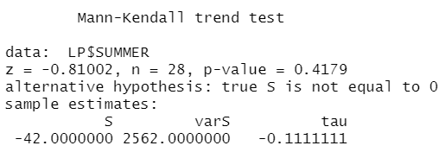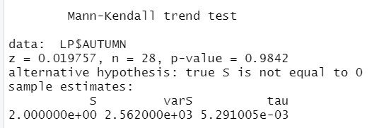

## Sens slope

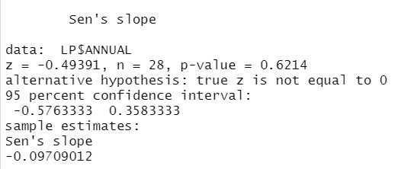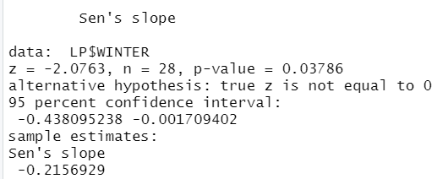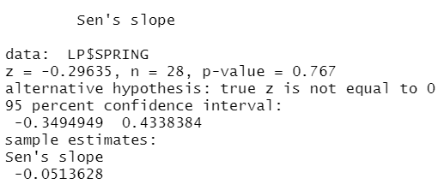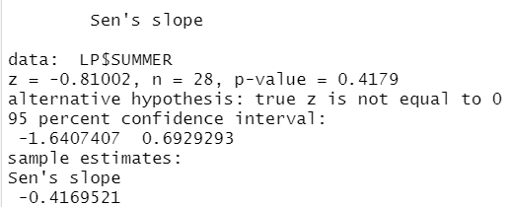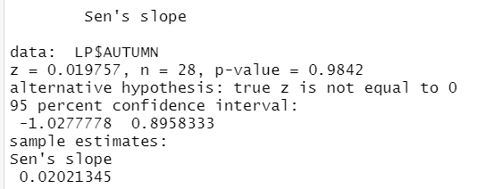

# North West

## Pettitt test

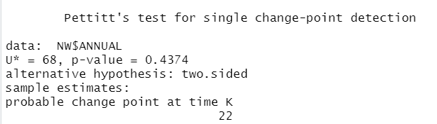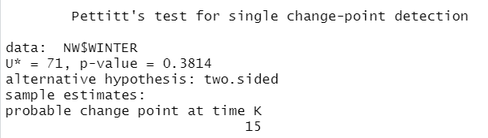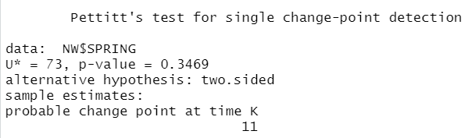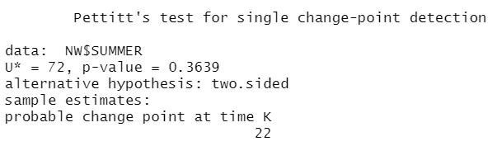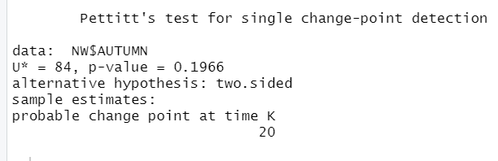

## Mann-Kendall test

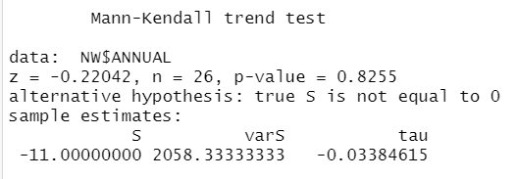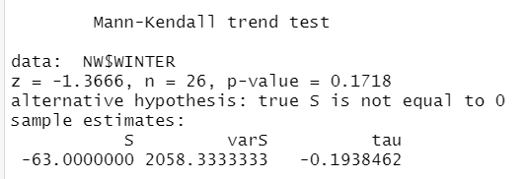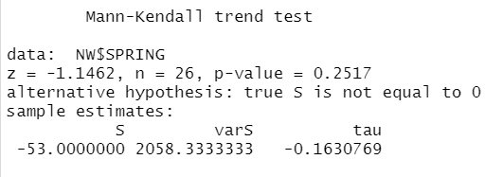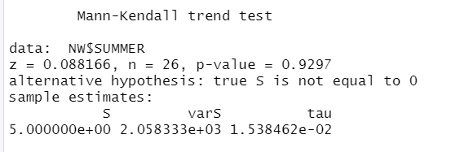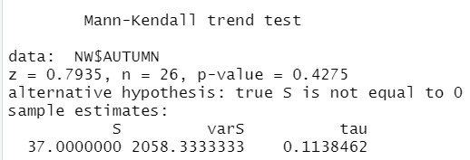

## Sens slope

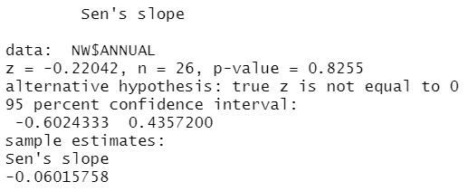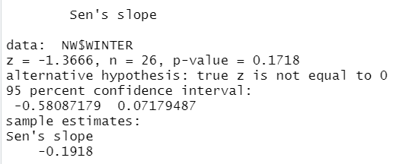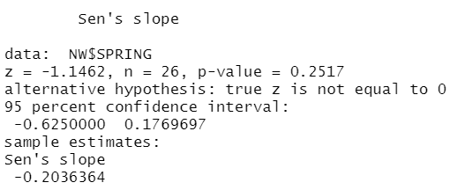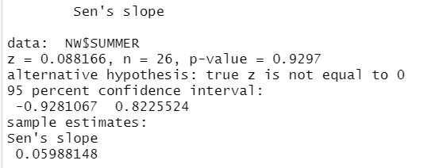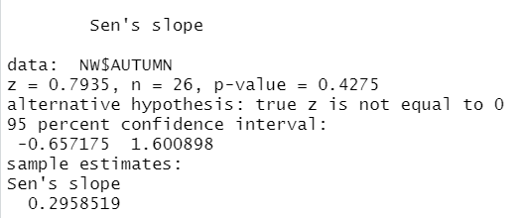

# Mpumalanga

## Pettitt test

## Mann-Kendall test

## Sens slope

